

Too Good To Go: Strategic Market Expansion Report – New Regions Analysis


Author: Yenam Dossou & Ibnouali Anas
January 2026

Table des matières
1. TOO GOOD TO GO: THE COMPANY 3
GLOBAL PRESENCE: WHERE IS TGTG LIVE? 3
REAL IMPACT (2023-2024) 4
2. Three‑Country Screening 5
3. Why Mexico (CDMX First) 6
3.1 Demand & Supply Signals 6
3.2 Digital Readiness: 7
3.3 Pricing Context: 7
3.4 Potential User Base (Metro CDMX) — top‑down 8
4. Entry Model & Launch Strategy 9
Expansion Model: Direct Growth 9
Competitive Landscape 9
Our Competitive Posture 9
5. Marketing Strategy & Brand Adaptation 10
Tone & Localization 10
Marketing Channels 10
6. Logistics, CX & Compliance 11
7. Cost of Installation & Local Setup (CDMX) 11
8. Demand & Adoption — Year‑1 Scenarios (CDMX) 12
9. Local Suppliers & Partnerships 12
10. Differentiation 13
11. Key Risks & Mitigations 13
12. KPIs for Pilot 13
13. Timeline (Indicative) 13
14. Country Notes (for the three markets) 13
Conclusion 14
References (Key Sources) 15

1. TOO GOOD TO GO: THE COMPANY
Founded in 2016 in Copenhagen, Denmark, Too Good To Go is a social-impact driven technology company that has become a global leader in food waste reduction. The company was created in response to a growing awareness of the massive scale of food waste worldwide and the lack of simple, scalable solutions to address it.
Today, Too Good To Go operates from its headquarters in Copenhagen, with major operational hubs such as London, which oversees UK activities. The company is led by CEO Søren Stephansen, who has played a key role in scaling the company internationally while preserving its mission-driven DNA.
Too Good To Go has raised over €100 million through multiple funding rounds, including Series C and Series D, attracting prominent international investors. This strong financial backing has enabled the company to invest heavily in technology, international expansion, marketing, and partnerships. As a result, Too Good To Go has achieved unicorn status, with a valuation exceeding €1 billion, confirming both its economic viability and strategic relevance.

GLOBAL PRESENCE: WHERE IS TGTG LIVE?
Too Good To Go operates in 17+ countries across Europe, North America, and beyond. Here's the current footprint:
- Denmark (2016) - 2,000+ restaurants, 500k+ users
- UK (2017) - 4,500+ restaurants, 2M+ users
- Sweden (2017) - 2,500+ restaurants, 800k+ users
- Norway (2017) - 1,500+ restaurants, 400k+ users
- Finland (2017) - 1,200+ restaurants, 300k+ users
- Germany (2018) - 5,000+ restaurants, 1.5M+ users
- France (2018) - 3,500+ restaurants, 1.2M+ users
- Netherlands (2018) - 2,000+ restaurants, 600k+ users
- Belgium (2018) - 800+ restaurants, 200k+ users
- Italy (2019) - 1,500+ restaurants, 400k+ users
- Spain (2019) - 2,000+ restaurants, 700k+ users
- Poland (2019) - 1,200+ restaurants, 300k+ users
- Switzerland (2019) - 1,000+ restaurants, 250k+ users
- Canada (2020) - 1,500+ restaurants, 500k+ users
- USA (2020) - 3,000+ restaurants, 800k+ users
- Australia (2021) - 1,000+ restaurants, 300k+ users
- Japan (2022) - 500+ restaurants, 100k+ users

Global Totals: ~40,000+ partner businesses | 20+ million active users | €30M+ GMV annually

REAL IMPACT (2023-2024)
- Active Users: 20+ million (monthly active)
- Partner Businesses: 40,000+ restaurants, bakeries, stores, hotels
- Food Rescued: 500,000+ TONS from landfill
- CO2 Prevented: 1.2 MILLION tons CO2 equivalent
- Meals Sold (Annually): 50+ million meals at discount
- Revenue (Estimated 2023): €300-400 million GMV
- Waste Prevented/Day: 1,400+ tons globally
- Countries Operating: 17 active + planning expansion

This report outlines a data-driven international expansion plan, leveraging market analytics to identify key growth opportunities in new regions.

Three‑Country Screening
We initially assessed Mexico, United Arab Emirates (UAE), and Ivory Coast across impact potential, market depth, and digital readiness.
Highlights:
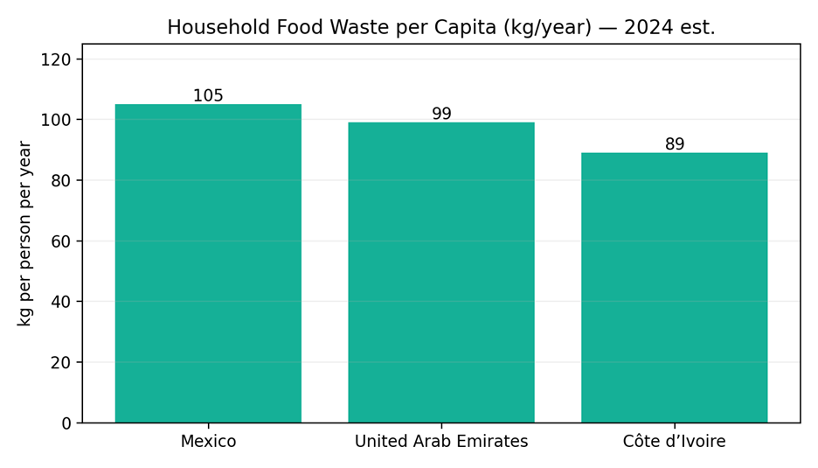
Fig. 1 — Household food waste per capita (kg/year). Source: WorldPopulationReview (compiled from UNEP Food Waste Index 2024); UNEP Food Waste Index 2024.
Data indicates that these three regions exhibit disproportionately high rates of household food waste per inhabitant
- Mexico shows high per‑capita household food waste (~105 kg/year) and very large urban agglomerations where surplus and demand meet.
- UAE has substantial hospitality-driven surplus and strong ESG pressure on hotels/caterers to measure and reduce waste; data‑rich reporting aligns with our value proposition.
- Ivory Coast presents social impact potential and growing urban food businesses, but purchasing power and digital infrastructure suggest sequencing it after Mexico.

3. Why Mexico (CDMX First)

3.1 Demand & Supply Signals
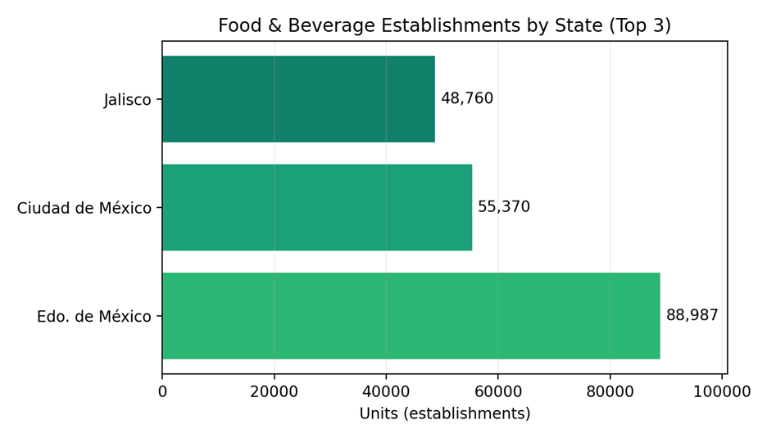
Fig. 2 — Food & beverage establishments — top states. Source: Data México (DENUE, May 2025).

• Dominance of Edo. de México: With 88,987 units, the State of Mexico significantly outperforms the other regions, likely due to its massive population density and urban sprawl surrounding the capital.
• The Capital’s Strong Position: Ciudad de México ranks second with 55,370 units, maintaining its status as a primary commercial and gastronomic hub despite having fewer total establishments than its neighboring state.
• Jalisco’s Regional Influence: Ranking third with 48,760 units, Jalisco (home to Guadalajara) cements its position as the leading food and beverage market in Western Mexico.

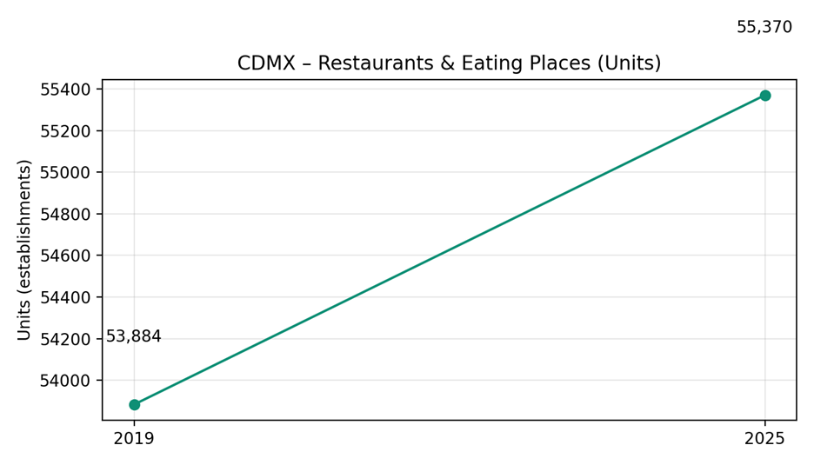
Fig. 3 — CDMX restaurants & eating places (units), 2019 vs 2025. Source: INEGI Censos Económicos 2019 (CDMX); Data México (DENUE, May 2025).

3.2 Digital Readiness:
Smartphone penetration in Mexico reached ~95.7% of active mobile lines (Q3‑2024), enabling an app‑only model and cost‑efficient acquisition through TikTok/Instagram/Maps.
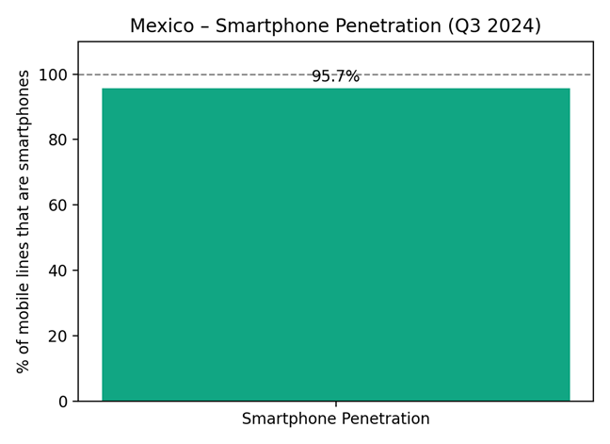
Fig. 4 — Smartphone penetration (Q3‑2024). Source: The Competitive Intelligence Unit (The CIU).

3.3 Pricing Context:
Food inflation is moderate, supporting value messaging (“Salva comida. Salva dinero.”).
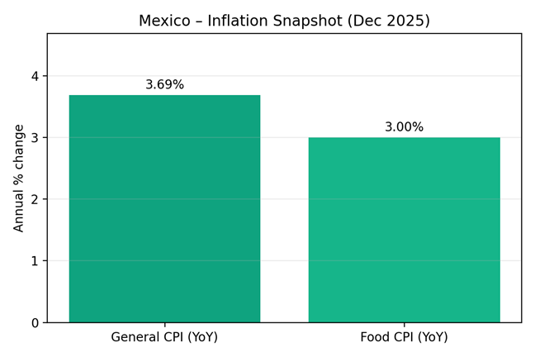
Fig. 5 — Inflation snapshot (Dec 2025). Source: INEGI CPI; INEGI via TradingEconomics (Food CPI).

3.4 Potential User Base (Metro CDMX) — top‑down
Metro population: ~22,752,000. Assuming 80% aged 15+ and 95.7% smartphone adoption among adults → Potential app‑ready adults ~17,418,931.
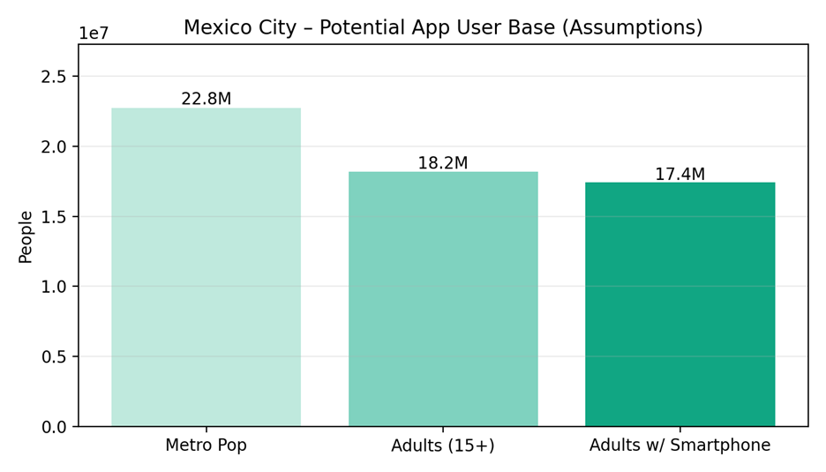
Fig. 6 — Potential app user base (assumptions stated). Sources: Macrotrends (metro population 2025); The CIU (smartphones).

4. Entry Model & Launch Strategy

Expansion Model: Direct Growth
We will execute a Direct Expansion model to maintain full control over brand equity, operational standards, and data integrity. The rollout is structured into three strategic phases:
- Pilot Phase: Launch in Mexico City (CDMX) to establish the core engine.
- Secondary Expansion: Scale to high-density hubs (Guadalajara, Monterrey, Puebla, Querétaro).
- National Scaling: Full nationwide deployment once unit economics and KPIs are validated.

Competitive Landscape

Direct Competitor: Cheaf (Marketplace Surprise-Bag Model)
- Model: Pickup-only marketplace (similar to Too Good To Go) offering "Surprise Bags" at 50–70% discounts across bakeries, cafés, and supermarkets.
- Footprint: 1M–3.5M users and 1,000–1,600 stores across ~25 Mexican cities; currently expanding regionally.
- Signals: Strong partnership portfolio (Maison Kayser, El Globo, Sanborns, Aranzazu) and high sell-through rates (8/10 bags).

Adjacent Competitor: Kigüi (Cashback & B2B Solutions)
- Model: Originally a consumer cashback app (40–60% off near-expiry items).
- Pivot: In 2024–2025, shifted focus toward B2B/AI (Kigüi For Business) to help retailers monitor expiry dates and automate markdowns.
- Edge: Backed by AWS Impact Accelerator and The Yield Lab Latam. While they compete for supermarket surplus, they are not a 1:1 substitute for the "Surprise Bag" consumer experience.

Our Competitive Posture
To displace incumbents and capture market share, we will execute a five-point strategy:
- Chain-First Acquisition: Secure multi-city agreements with national chains. We differentiate by providing Enterprise Impact Dashboards that track CO₂e savings and meal metrics for corporate ESG reporting.
- Operational Quality: Implementing tighter pickup windows and issue-rate guarantees. We provide merchant coaching to maximize sell-through and offer SLA-based support via a dedicated WhatsApp Business channel.
- "Surround" Strategy: Use supermarkets and hotel buffets as anchor locations, then densify small-to-medium business (SMB) clusters around these anchors to boost consumer liquidity and reduce travel time.
- Margin-Preserving Pricing: Protect merchant margins by avoiding permanent rate cuts; instead, utilize time-boxed launch promotions to drive initial user acquisition.
- Mission & Compliance: Align brand messaging with UNEP waste data and municipal sustainability goals, ensuring full compliance with local regulations (e.g., NOM-051).

5. Marketing Strategy & Brand Adaptation

Tone & Localization
The brand tone in Mexico should be friendly, optimistic, and community-oriented, reflecting local values around sharing, family, and affordability. Communication must remain simple, positive, and action-oriented, emphasizing collective impact rather than guilt.
Key localized brand messages include:
- “Salva comida. Salva dinero.” (Save food. Save money.)
- “Comida buena, precio justo.” (Good food, fair price.)
- “Juntos contra el desperdicio.” (Together against food waste.)
These messages directly link economic value with environmental responsibility, which is particularly effective in a price-sensitive context.

Marketing Channels
The go-to-market strategy relies on digital-first, low-cost, high-impact channels, aligned with Mexico’s strong mobile and social-media usage:
- TikTok & Instagram Reels for viral, short-form educational content and user testimonials
- Google Maps listings to improve merchant discoverability at the point of intent
- WhatsApp Business for merchant onboarding, support, and operational communication
- Partnerships with NGOs and sustainability organizations to enhance credibility and PR impact
- In-store QR codes at partner merchants to drive app downloads at physical touchpoints
- Street teams and local activations in high-traffic urban areas during launch phases
- PR campaigns focused on sustainability, food waste reduction, and social impact

6. Logistics, CX & Compliance
Too Good To Go operates as a digital marketplace and does not handle food directly. Consumers reserve Surprise Bags via the app and collect them in-store during fixed pickup windows defined by merchants. No delivery is involved, keeping operations simple and scalable.
Merchant onboarding is standardized through a dedicated dashboard, with clear guidelines for surplus preparation, pickup management, and customer interaction. Branded materials (QR codes, posters) support in-store activation, while operational support is provided via WhatsApp Business.
From a compliance perspective, operations in Mexico are aligned with NOM-051 labeling regulations and local food safety standards for near-expiry products. Responsibility for food quality remains with merchants, supported by Too Good To Go’s best-practice guidance

7. Cost of Installation & Local Setup (CDMX)
We have estimated our deployment costs. Although these are estimates, they are quite accurate compared to the costs of deploying in regions such as.USA.
Category | Estimated Cost (USD)
Local team (first 6 months) | 30,000–45,000
Marketing launch | 15,000–25,000
Merchant kits | 3,000
Legal + accounting | 3,000–6,000
Office (optional) | 1,000 / month
Travel & meetings | 2,000
Contingency | 5,000

Total estimated investment: $60,000–$90,000 for a strong launch in CDMX.

8. Demand & Adoption — Year‑1 Scenarios (CDMX)
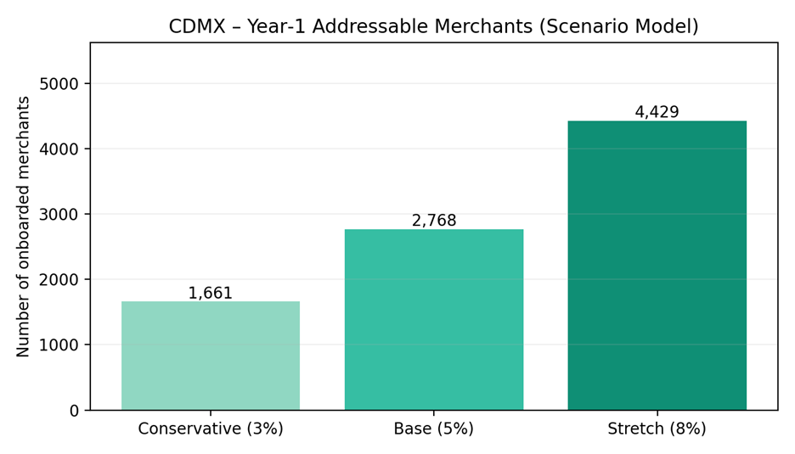

Fig. 7 — Onboarded merchants scenarios from CDMX base (DENUE May 2025).
Scenario | Onboarded merchants (count)
Conservative (3%) | 1,661
Base (5%) | 2,768
Stretch (8%) | 4,429

9. Local Suppliers & Partnerships
- Too Good To Go will work with bakeries, cafés, restaurants, supermarkets (Soriana, Chedraui, La Comer), as well as hotels and buffets.

- Printed materials, merchant kits, promotions, and event logistics will be sourced locally to reduce costs, speed up deployment, and support local businesses.

10. Differentiation
- Global brand trust & stronger national‑chain partnerships
- Superior app technology & user experience
- Community‑driven mission and ESG reporting (CO₂ saved, meals rescued) for merchants

11. Key Risks & Mitigations
- Merchant churn → Mitigation: data‑backed coaching, pickup‑window optimization, featured placement incentives.
- Quality at pickup → Mitigation: templated prep & labeling, rating triggers, spot checks.
- Regulatory changes → Mitigation: local counsel; template SOPs aligned to NOM‑051.

12. KPIs for Pilot
- Active merchants (M) & net adds/week
- Surprise Bags listed vs. sold (%) and daily sell‑through
- NPS at pickup; order issue rate (%)
- Rescued meals & CO₂e avoided

13. Timeline (Indicative)
- Month 0–1: legal, pilot merchant LOIs, city team hiring
- Month 2: merchant onboarding sprint, campus & street activation
- Month 3–4: PR + supermarket/hotel chains; iterate pickup windows
- Month 5–6: reach Base scenario; prep Guadalajara/Monterrey launch

Conclusion
Mexico represents a high-potential market for Too Good To Go. With a direct expansion model, localized branding, strong merchant partnerships, and a structured and low-risk rollout, TGTG can quickly establish itself as a leading anti-food-waste platform in the country.
Starting with Mexico City (CDMX) allows rapid testing and scale. Reaching the Base scenario by Month 6 creates a solid foundation to expand into Guadalajara and Monterrey, before moving toward national coverage.

References (Key Sources)
• UNEP — Food Waste Index Report 2024 (global scale, methodology)
• WorldPopulationReview — Country food‑waste per‑capita table (compiled from UNEP)
• Data México (Secretaría de Economía) — DENUE May 2025 restaurant/eating places counts
• INEGI — Censos Económicos 2019 (CDMX establishments); CPI dashboard
• Macrotrends — Mexico City metro population 2025
• The Competitive Intelligence Unit (The CIU) — Smartphone penetration Q3‑2024
• TradingEconomics (INEGI source) — Mexico food CPI (Dec 2025)

